

**Year 11 Biology ATAR – Unit 1**

**Test 1 – Biodiversity & Classification**

|  |
| --- |
| Name: |

|  |  |  |
| --- | --- | --- |
|  | Marks Available | Marks Achieved |
| Part 1 - Multiple choice | 15 |  |
| Part 3 - Short Answer | 30 |  |
| Part 3 – Extended Response | 10 |  |
| Total | 55 |  |

Assessment Time: 55 minutes

Weighting: 20%

**Section One: Multiple choice (15 Marks)**

Mark your answers on the grid below with a X.

|  |  |  |  |  |
| --- | --- | --- | --- | --- |
| Question |  |  |  |  |
| **1** | **A** | **B** | **C** | **D** |
| **2** | **A** | **B** | **C** | **D** |
| **3** | **A** | **B** | **C** | **D** |
| **4** | **A** | **B** | **C** | **D** |
| **5** | **A** | **B** | **C** | **D** |
| **6** | **A** | **B** | **C** | **D** |
| **7** | **A** | **B** | **C** | **D** |
| **8** | **A** | **B** | **C** | **D** |
| **9** | **A** | **B** | **C** | **D** |
| **10** | **A** | **B** | **C** | **D** |
| **11** | **A** | **B** | **C** | **D** |
| **12** | **A** | **B** | **C** | **D** |
| **13** | **A** | **B** | **C** | **D** |
| **14** | **A** | **B** | **C** | **D** |
| **15** | **A** | **B** | **C** | **D** |

**Part 1: Multiple Choice**

DO NOT WRITE ON THIS PAPER**:** Use the Multiple Choice answer sheet

1. Scientists describe biodiversity as:

1. all of the endangered species from a particular part of the world.
2. the variety of life on Earth.
3. the study of living systems and how diverse they are.
4. the study of cellular processes and how they vary.

2. In which of the following would you expect to find the least biodiversity?

1. An Australian rainforest containing a variety of habitats
2. A population of koalas in an Australian zoo that arose from one breeding pair
3. The population of green turtles breeding on Raine Island in the Great Barrier Reef
4. A eucalypt forest regenerating 2 years after a fire

3. The Baikal seal is a species of earless seal found only in the fresh water of Lake Baikal in Siberia, Russia. The fact that it lives nowhere else means it is an example of:

1. a phylogenetic species.
2. an endemic species.
3. a morphological species.
4. an introduced species.

4. The structure and organisation of ecosystems are affected by which of the following biotic factors?

(a) Nutrient availability, soil pH, temperature

(b) Predation, competition, disease

(c) Light intensity, rainfall, population dynamics

(d) Temperature, predation, amount of fresh water

5. Which of the following features is not associated with Domain Eukaryota?

1. Organisms in this domain can be found just about everywhere.
2. Some organisms in this domain can produce their own food through photosynthesis.
3. Organisms in this domain can be unicellular or multicellular
4. Organisms in this domain do not have membrane bound organelles

6.  The division of life into Domains is based on:

1. cellular characteristics, including the presence of DNA contained within a nucleus.
2. cellular characteristics, including living in extreme environments such as areas of high temperature.
3. similarity of physical features, such as colour and shape of the organisms.
4. differences between physical features, such as colour and shape of the organisms.

7. Sea sponges, earthworms, march flies, and echidnas are all classified into the same:

1. Family.
2. Genus.
3. Phylum.
4. Kingdom.

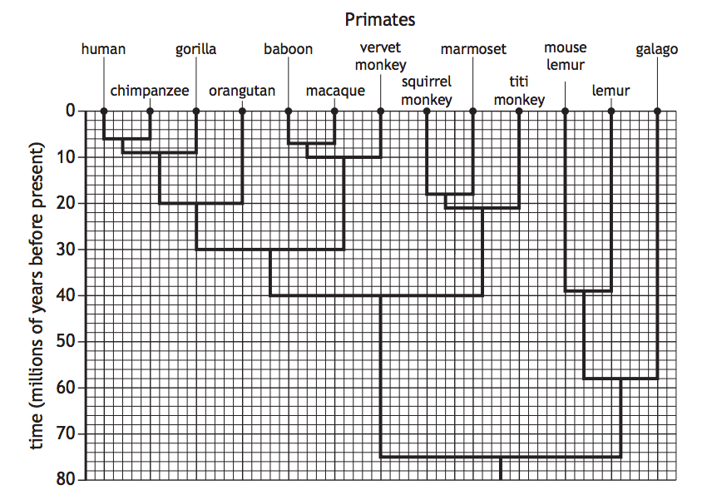8. The diagram shows the divergence of lineages in the evolution of some primates.

Which row of the table identifies the time that the last common ancestor of vervet monkeys and humans existed, and the number of other species that shared this common ancestor?

|  |  |  |
| --- | --- | --- |
|  | Time (millions of years before present) | Number of other species that shared this common ancestor |
| a) | 30 | 5 |
| b) | 30 | 11 |
| c) | 40 | 8 |
| d) | 75 | 11 |

9. Bufo marinus is a toad native to the Americas. In Australia, we know this animal as a cane toad. Which part of its scientific name tells scientists the genus of the cane toad?

1. Bufo
2. marinus
3. Neither Bufo nor marinus
4. Both the words Bufo and marinus are required to determine the genus.

10. Organisms in the Cnidarian phyla have

1. have bilateral symmetry.
2. have cell walls made of chitin.
3. are able to photosynthesise.
4. Have radial symmetry.

11. There are several animals known commonly as Moles. Marsupial Moles, *Notoryctes typhlops*, is a marsupial found in southern Australia. The Golden Mole, *Chrysochloris asiatica*, is a placental mammal from Southern Africa. These two Moles:

1. are very closely related because they are both types of mole.
2. are only distantly related because they reproduce in different ways.
3. are different species, but are from the same genus.
4. are similar in appearance, so would be able to reproduce fertile offspring if they were in the same habitat.

Question 12 refers to the table below.

|  |  |  |  |  |  |
| --- | --- | --- | --- | --- | --- |
| **Organism** | **A** | **B** | **C** | **D** | **E** |
| Order | Marsupalia | Marsupalia | Carintae | Carnivora | Carnivora |
| Species | Thylacinus cynocephalus | Dasyurus geoffroii | Troglodytes troglodytes | Felis tigris | Felis domesticus |
| Common Name | Tasmanian tiger | Tiger-cat | Wren | Tiger | Cat |

12. Which of the organisms described above would be the most similar?

1. A and D
2. A and C
3. B and E
4. D and E

13. Of the cladograms shown below, which one shows a different evolutionary history from the others?

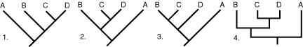

1. b) c) d)

14. The statement below gives information on a plant species.

1 *Solanum lycopersicum* has a vascular structure to its leaves and stem.

2 *Solanum lycopersicum* has seeds.

3 *Solanum lycopersicum* uses fruit to disperse its fertilised seeds.

From this information, which plant phyla does *Solanum lycopersicum* belong to?

1. Ferns
2. Mosses
3. Gymnosperms
4. Angiosperms

15. Using the phylogenetic tree (right), which of the following organisms are more closely related?

1. 1 and 2
2. 2 and 3
3. 3 and 4
4. 4 and 5

**Question 16 (4 marks)**

a) List, in order from the smallest group to the largest group, the taxonomical hierarchy of classification. (1 mark)

Species, Genus, Family, Order, Class, Phylum, Kingdom, Domain (1)

b) Which taxa contains organisms that are most similar? (1 mark)

Species (1)

c) Give two advantages of using this system over using common names. (2 marks)

Any 2 for 1 mark each:

* Communication is easier between scientists around the world
* Genus gives information as to similar organisms
* Avoids confusion over common names/variation of common names for species

**Question 17 (2 marks)**

List two biotic and two abiotic factors/features that would be present in a polar ecosystem.

|  |  |
| --- | --- |
| Biotic (any 2 for 1 mark) | Abiotic (any 2 for 1 mark) |
| * Animals * Plants * Bacteria * Competition * Any reasonable answer | * Light * Temperature * Gases * Water * Any reasonable answer |

**Question 18 (5 marks)**

Define the following two species concepts: biological species concept and phylogenetic species concept. Provide an example that supports each species concept. Explain why the biological species concept cannot be used with fossils.

1 mark each:

* Biological species concept – the ability to produce fertile offspring between organism
* Phylogenetic species concept – group of organisms from a common ancestor that share defining or derived traits.
* Example x 2
* Fossils don’t reproduce so no way to know if fossilised species could create fertile offspring.

**Question 19 (6 marks)**

Examine the dichotomous key presented below and answer the questions which follow. It is used to classify insects to the taxa Order.

**Dichotomous key to insect Orders**

|  |  |  |
| --- | --- | --- |
| 1a | Wings present | Go to 2 |
| 1b | Wings absent | Order Apterygota |
| 2a | With one pair of wings | Order Diptera |
| 2b | With two pairs of wings | Go to 3 |
| 3a | Front wings of coarser texture than hind wings | Go to 4 |
| 3b | All wings membranous. May be hair or scale covered | Go to 8 |
| 4a | Basal two-thirds of front wing thickened, remainder membranous | Order Hemitera |
| 4b | Whole of front wing of same texture | Go to 5 |
| 5a | Front wings hard and horny | Order Coleoptera |
| 5b | Front wings slightly thickened with distinct veins | Go to 6 |
| 6a | Mouthparts of piecing type | Order Hemiptera |
| 6b | Mouthparts of biting type | Go to 7 |
| 7a | Hind legs much longer than other legs | Order Orthoptera |
| 7b | All legs more or less equal in length | Order Blattodea |
| 8a | Wings and body completely covered by fine scales or hairs | Go to 9 |
| 8b | Wings only covered by fine scales or hairs | Order Plecoptera |
| 9a | Hind and front wings linked by a row of hooks. Front of abdomen narrowed to form a ‘waist’ | Order Hymenoptera |
| 9b | Wings not joined. No ‘waist’ | Order Lepidoptera |

The diagram presented below illustrates an animal from the class Insecta. Use the dichotomous key above and this labelled diagram to assist you to answer parts (a) and (b) below.

Coarse front wings (same texture throughout) Smooth hind wings

With thickened and distinct veins

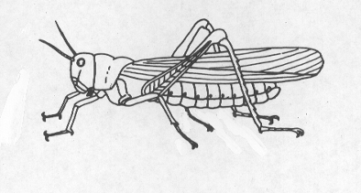

Biting mouth parts

a) Which Order does this insect belong to? Orthoptera (1 mark)

b) State THREE features possessed by this insect. (3 marks)

Any 3 for 1 mark each:

* Smooth hind wings
* Wings present
* With two pairs of wings
* Front wings of coarser texture than hind wings
* Whole of front wing of same texture
* Front wings slightly thickened with distinct veins
* Mouthparts of biting type
* Hind legs much longer than other legs

c) Identify two features that Coleoptera and Hemiptera share. (2 marks)

Any 2 for 1 mark each:

* Whole of front wing of same texture
* Two pairs of wings
* Wings present
* Front wing coarser than hind wing

**Question 20 (3 marks)**

Compare and contrast the features of organisms that belong to the phylum Cordata and phylum Arthropoda.

|  |  |  |
| --- | --- | --- |
|  | **Cordata** | **Arthropoda** |
| Contrast  (2 marks)  Must have both C and A columns for 1 mark | * Majority vertebrates | * All invertebrates |
| * endoskeleton | * exoskeleton |
| * no body segments | * body segments |
|
| Compare  (1 mark)  Must have comparison (whereas/compared to/both have/reference to similarities) | * Both have bilateral symmetry * Both have jointed limbs | |

**Question 21 (10 marks)**

a) The table below shows the common and scientific names of five species of fish.

|  |  |
| --- | --- |
| **Common Name** | **Scientific name** |
| Atlantic Herring | *Clupea harengus* |
| Australian Herring | *Arripis georgianus* |
| Cardinal Fish | *Apogon latus* |
| Horse-eye Jack | *Caranx latus* |
| Western Australian Salmon | *Arripis truttaceus* |

b)  What is the genus name of the Atlantic Herring? (1 mark)

Clupea (1)

c)  Which two species in the table are the most closely related to each other? Give a reason for your choice. (3 marks)

1 mark each:

* Australian Herring (Arripis georgianus)
* Western Australian Salmon (Aripis truttaceus)
* These are the only two of the species that occur in the same genus/ same genus name

Species names with genus capital letter and species lower case letter.

c) Below is a cladogram that is missing some of its information.

Use the derived characteristic matrix below the cladogram to fill in the blanks on the cladogram. (4 marks)

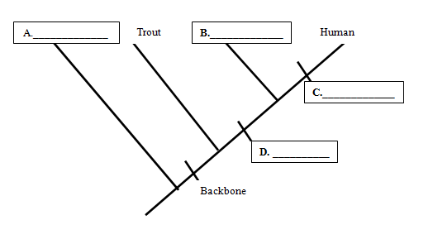

|  |  |  |  |
| --- | --- | --- | --- |
| **Organism** | **Derived Character** | | |
| **Backbone** | **Legs** | **Hair** |
| **Earthworm** | Absent | Absent | Absent |
| **Trout** | Present | Absent | Absent |
| **Lizard** | Present | Present | Absent |
| **Human** | Present | Present | Present |

1 mark each:

A: earthworm

B: lizard

C: hair

D: legs

(e) Which trait separates the least closely related organism from the other animals?(1 mark)

Backbone (1)

f) What is meant by the term ‘common ancestor’? (1 mark)

A species from which two different species both evolved (1)

**Part 3: Extended Response**

**Question 22 (10 marks)**

|  |  |
| --- | --- |
| **Description** | **Marks** |
| The scientists would have gathered (any three sets of the following) |  |
| * Genetic evidence * In the form of DNA | 1-2 |
| * They would have also looked at the physical characteristics of the whales * For example, body shape, presence of baleen plates, size of flukes etc | 1-2 |
| * They would have also looked at the reproduction of the whales * For example, length of pregnancy, timing of mating, when they give birth etc | 1-2 |
| * They would have looked to see if there was any interbreeding with other populations. * If there was this would suggest they were not the same species, if not it would suggest they were the different species | 1-2 |
| **Sub Total** | 6 |
| Any four of the following. |  |
| * Once these were identified they would use the hierarchical nature of classification * And assign a kingdom, phylum, class, order family genus species, * Given the new species of baleen whale shares more characteristics with other baleen whales * It would be placed in the same genus, but be given a different species name | 1-4 |
| **Sub Total** | **4** |
| **Total** | **10** |